# Lab 9. Up and Running with Tensorflow 20140557 Harim Kang

## Install Tensorflow and make Test project

* Step 1. Install Tensorflow
* Step 2. Check installed Tensorflow
* Code

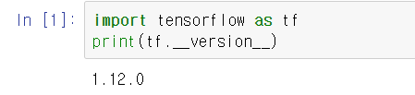

* Step 3. Make a Graph about the formula
* Code

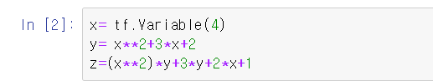

* Step 4. Initialize and evaluate step3's graph
* Code

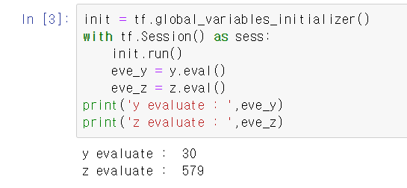

* Step 5. Make new graph and evaluate it
* Code

